https://dev318910.service-now.com/navpage.do
admin
Jan30
Activity 1 - Adding "Pune" to a User in ServiceNow
Step-by-Step: Adding "Pune" to a User in ServiceNow
Step 1: Create the Location Record
Before you can assign "Pune" to a user, it must exist in the system's location master.
- In the Filter Navigator, type cmn_location.list and press Enter (or go to User Administration > Locations).
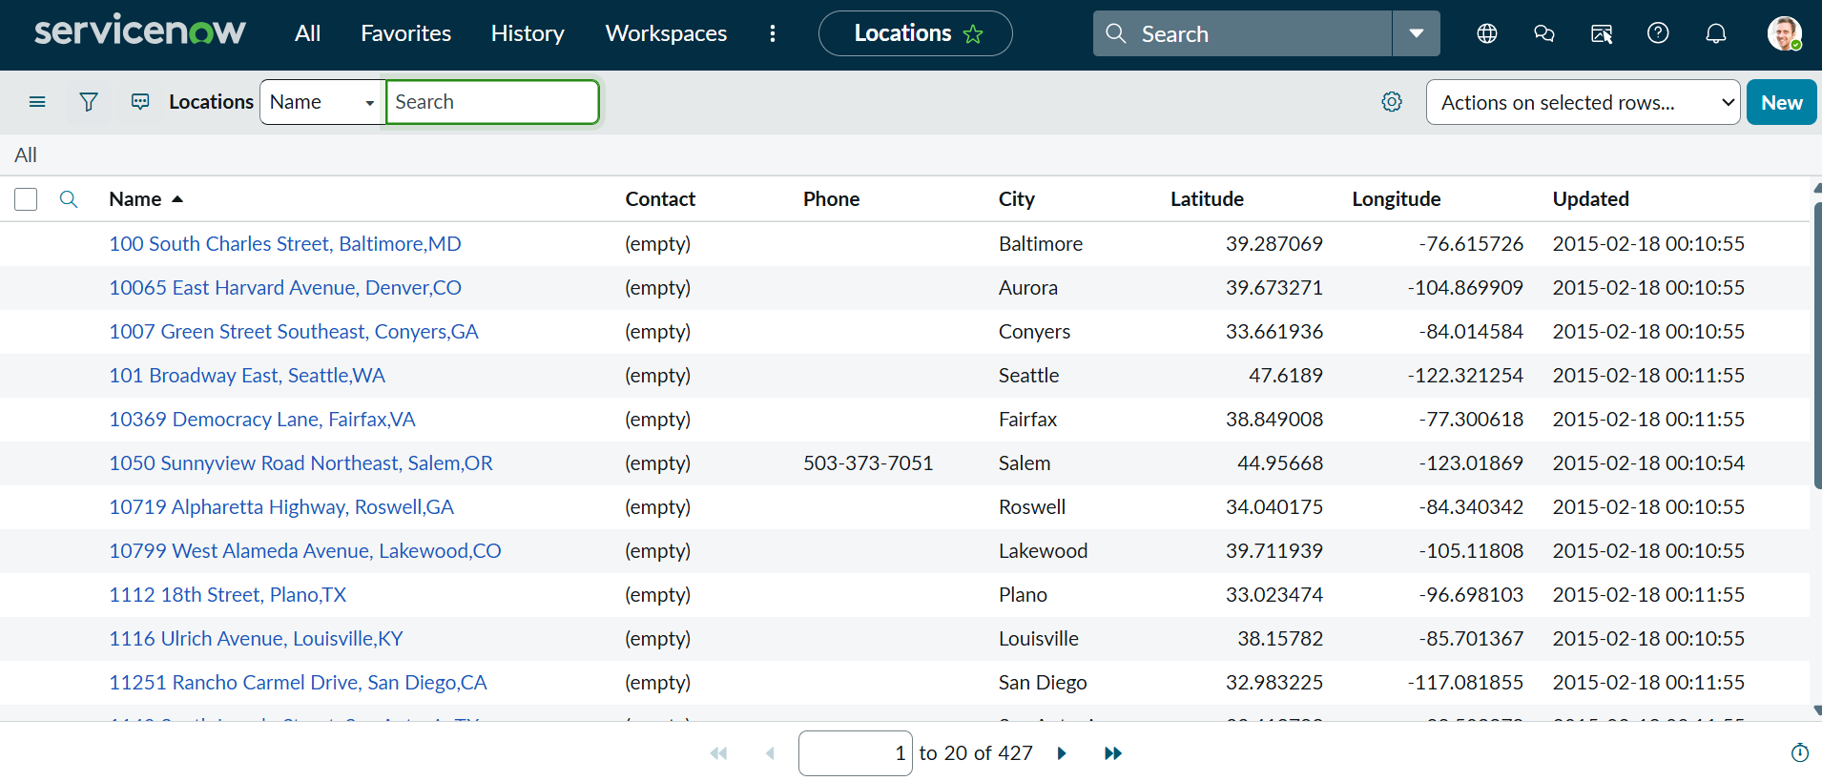
- Click the New button.
- Fill in the details:
  - Name: Pune
  - City: Pune
  - State / Province: Maharashtra
  - Country: India
  - Full Address: (Optional: Add the specific office address in Pune).
- Click Submit.
- 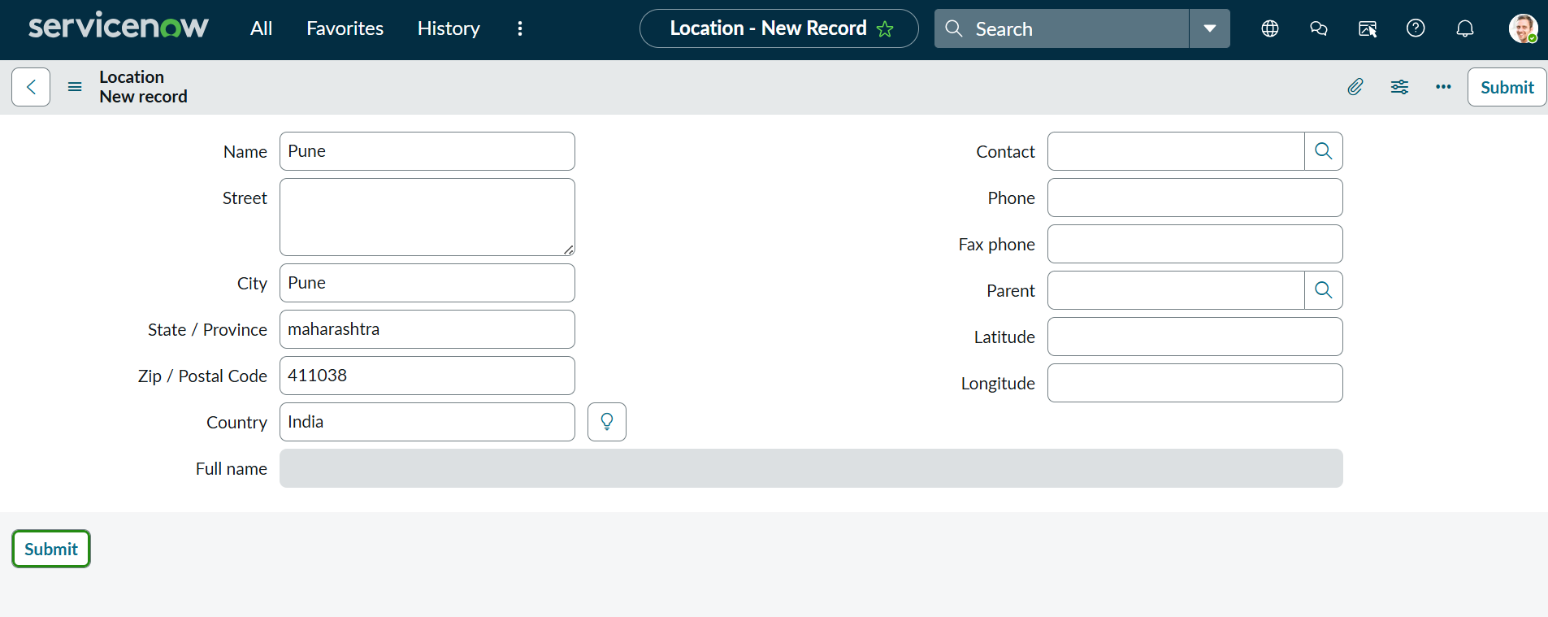
Step 2: Assign the Location to a User
Now that the location exists, you can link it to your specific user In the Filter Navigator, type sys_user.list (or go to User Administration > Users).
- Search for the User's name and open their record.
- Find the Location field.
  - Tip: If you don't see the Location field, use Form Layout (Right-click Header -> Configure -> Form Layout) to add it.
- Click the Magnifying Glass (Lookup) icon next to the Location field.
- Search for Pune and select it.
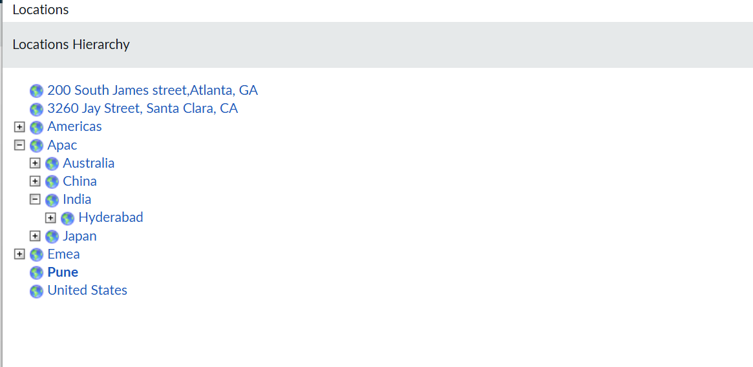
- Click Update.
Step 3: Verification (The "List View" Check)
To ensure the update was successful for your reporting:
- Go back to the User list (sys_user.list).
- Add the Location column to the list view using the gear icon.
- Filter by Location = Pune. You should now see your user listed there.
Activity 2 -Template creation and apply Template…

Create an incident template
Navigate to System Definition > Templates

Activity 3 – Understanding Client Script in ServiceNow

A Client Script in ServiceNow is a piece of JavaScript code that runs in the user's browser (the "client") rather than on the server.
Its primary purpose is to make the form interactive and "smart" by reacting to changes immediately, without the user having to click "Save" or "Submit."
The 4 Main Types of Client Scripts
When you create a Client Script, you must choose when it should run:
Type | When it runs | Example Scenario
onLoad | When the form first opens. | Make the "Resolution Notes" field hidden until the state changes.
onChange | When a specific field is changed. | Your Location Case: When the Caller changes, go fetch their Location and put it in the field.
onSubmit | When the user clicks Save/Submit. | Prevent submission if the "Description" is less than 10 characters.
onCellEdit | When a value is changed in a List view. | Prevent users from changing a Priority directly from the list.

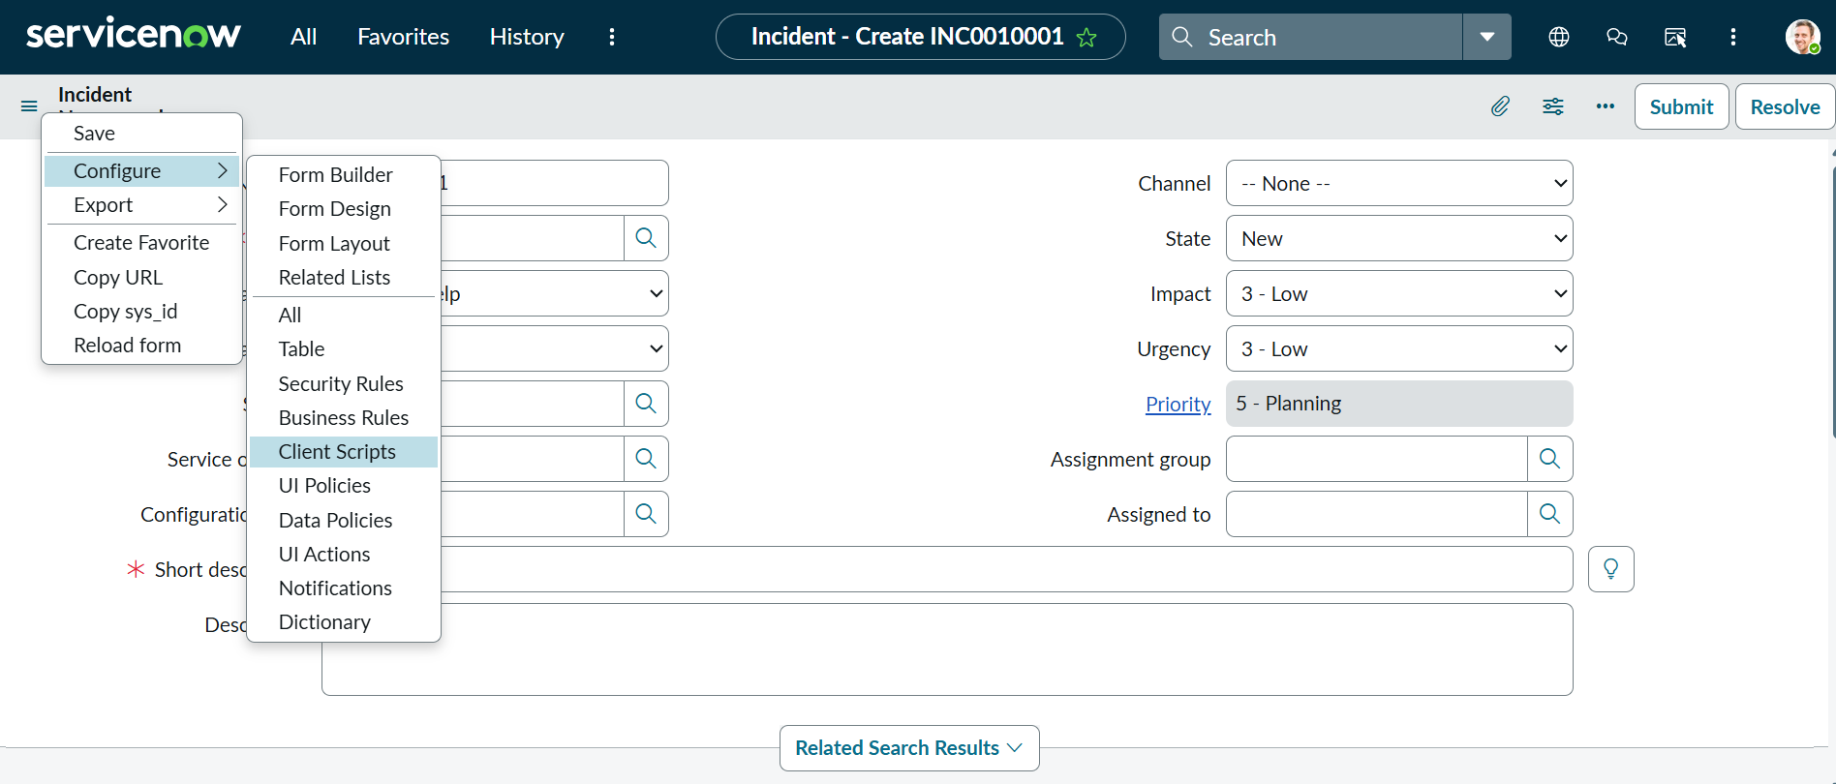
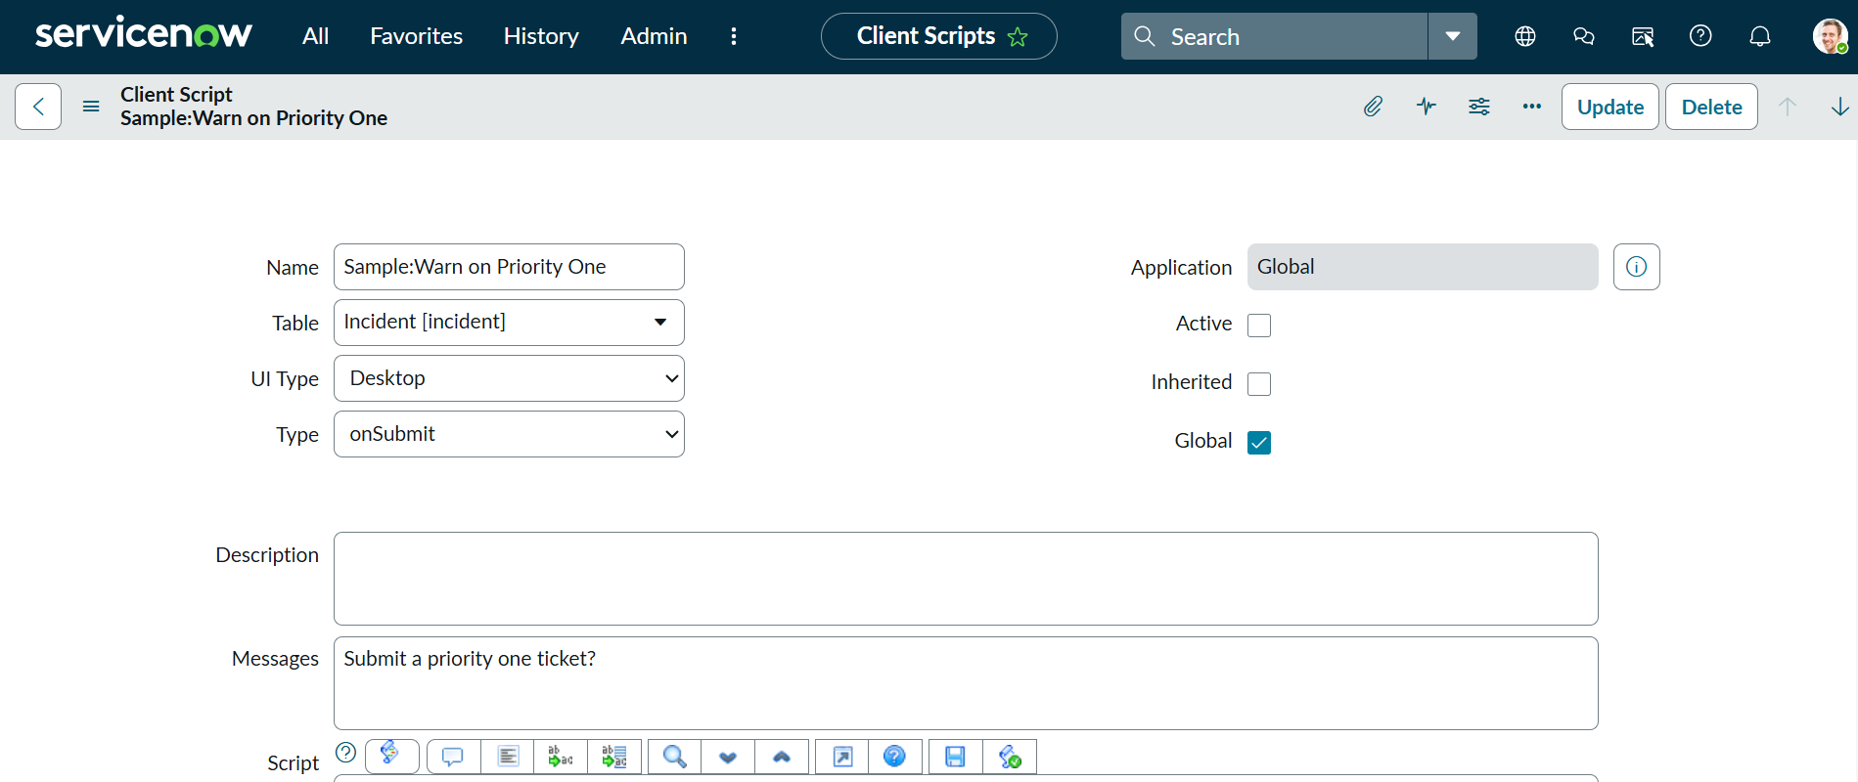
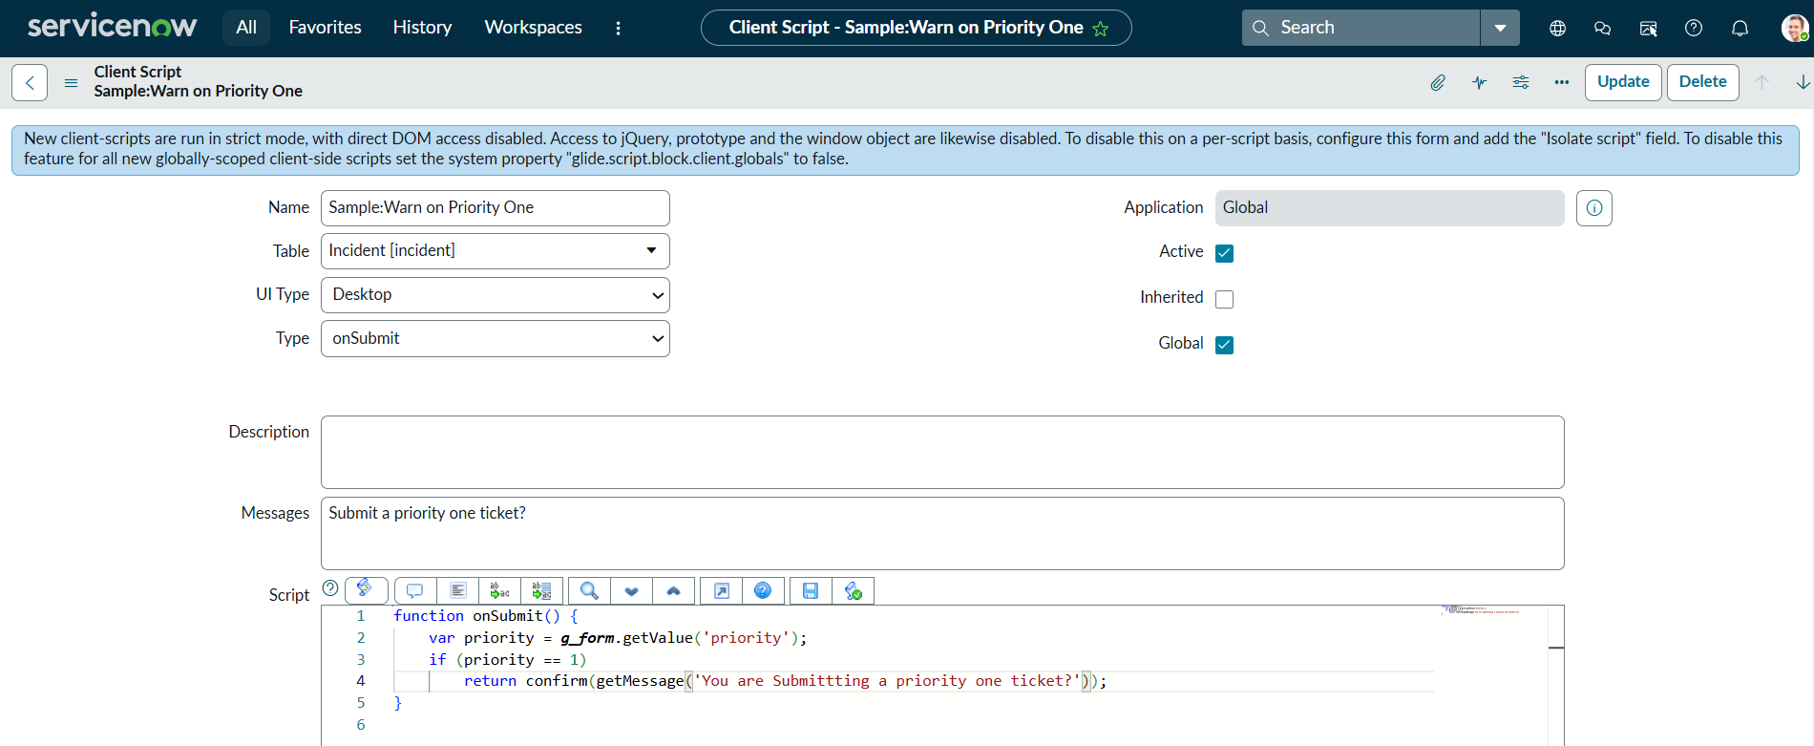

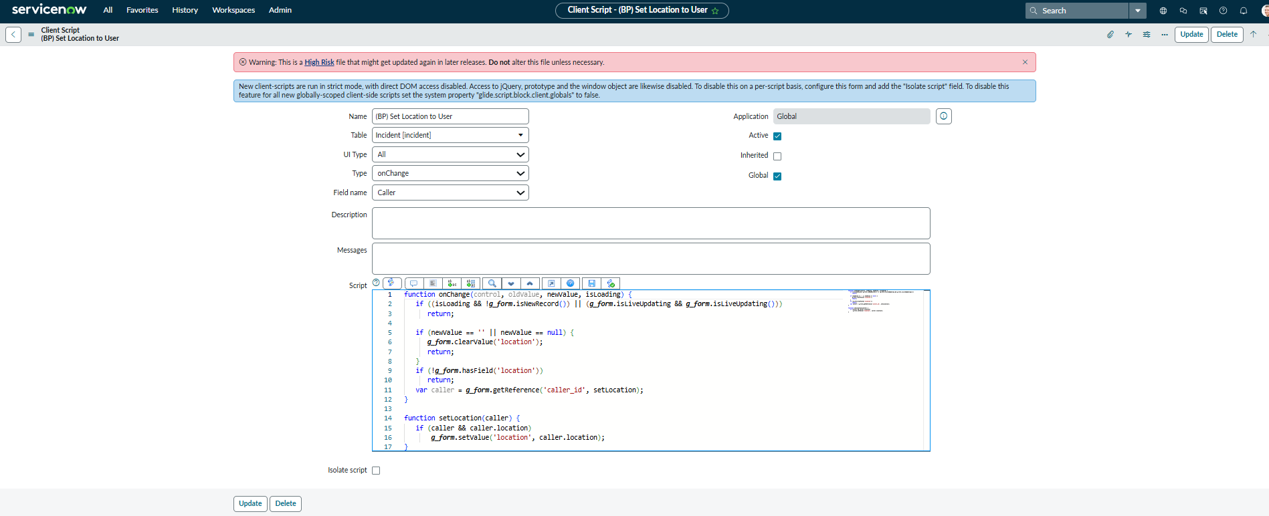

Activity 4 – Parent child relation in Incident Tickets.

